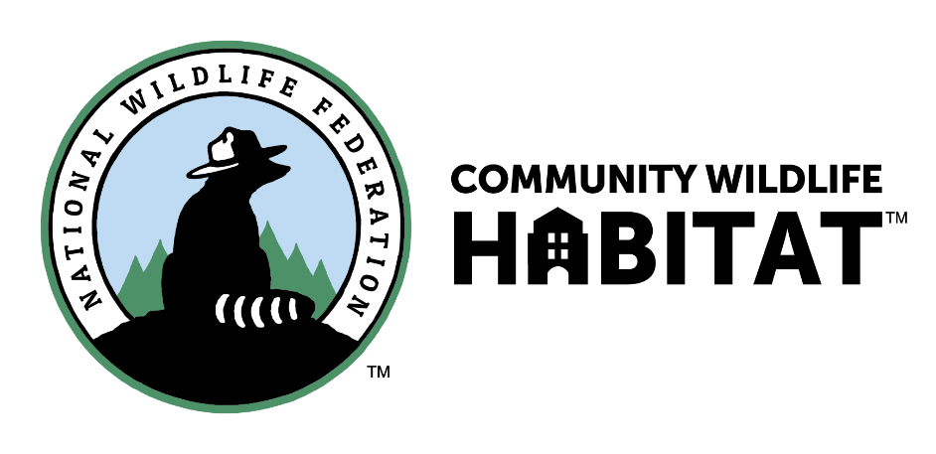
Somersworth is proud to be the first community in Northern New England to register for certification in the National Wildlife Federation’s Community Wildlife Habitat program.

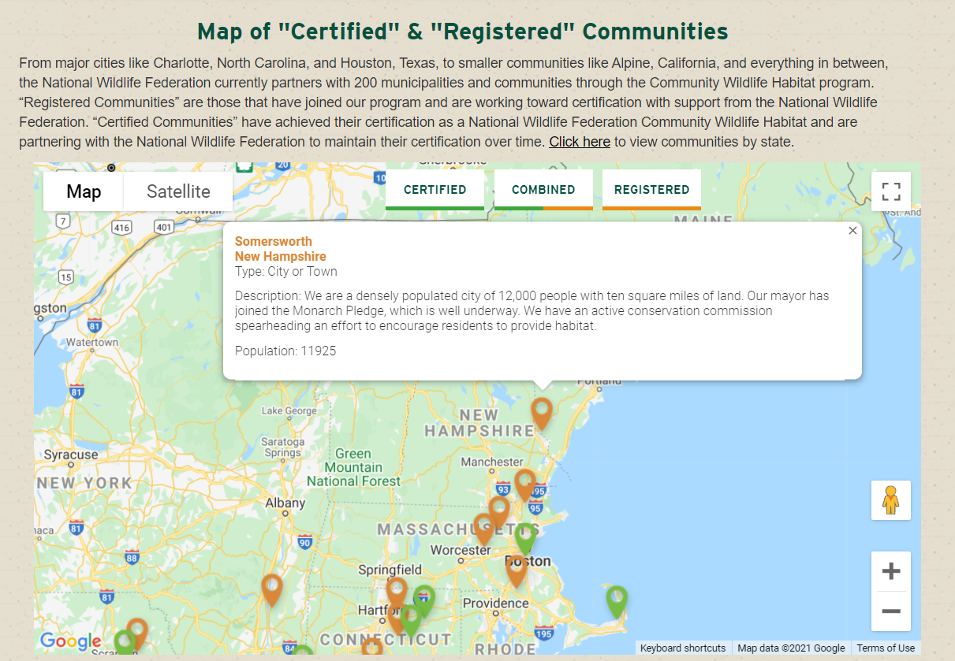
Wildlife habitat is becoming ever more fragmented, which is bad news for wildlife – especially in a time of climate change, when species will need to migrate to survive. Most of the habitat in the US is fragmented, meaning that it’s separated from other patches of habitat by development. An aerial view of Somersworth illustrates this.

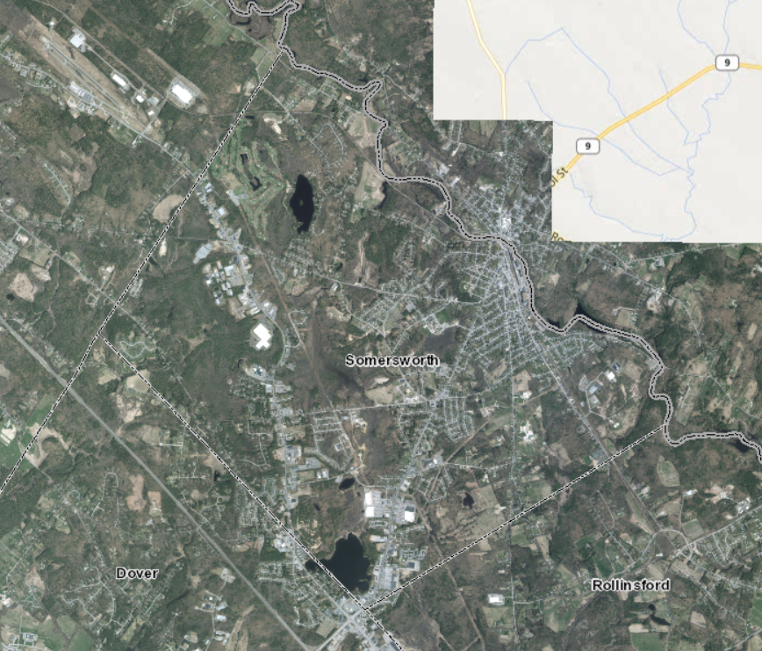
According to Mapping and Modeling the Biogeochemical Cycling of Turf Grasses in the United States - C. Milesi, somewhere around ten percent of New Hampshire’s area is covered by turf, which is a habitat desert. What if homeowners dedicated some portion of their yard toward habitat? In a densely populated city like Somersworth, the impact would be huge. It would help to blur and erase those lines of fragmentation. so that wildlife could pass through, and the more wildlife diversity, the more able the city will be to stand up to climate change’s impacts on humans.

So that’s why we’re doing it.

In order to become certified, a community must earn “Certification” Points and “Education and Outreach” Points. First, a certain number of homes, schools and common areas must become National Wildlife Federation Certified Wildlife Habitats by providing the four basic elements that all wildlife need: food, water, cover, and places to raise young. These requirements are based on population. For Somersworth, that number is between 150 and 175 parcels. The NWF Certified Wildlife Habitat program also requires sustainable gardening practices such as using rain barrels, reducing water usage, removing invasive plants, using native plants and eliminating pesticides.

Second, communities earn education and outreach points through a checklist that includes educating citizens at community events, hosting a native plant sale, organizing a clean-up, bringing new partners to the effort, and hosting workshops.

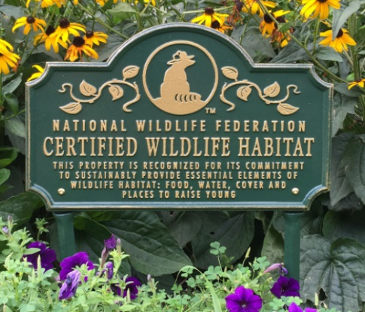
There was a $99 registration fee for the city, to cover materials and guidance. That cost was donated by a member of the Conservation Commission. There is a $20 application processing fee per certification, for those who would like to participate. Property signs, which are not required for certification, cost $99.

This is a long-term project, and we are just in the beginning phase of getting up to speed with the program. More information will come soon.

• Information on how to create a wildlife habitat can be found here: http://www.nwf.org/GardenFor-Wildlife/Create.aspx
• Additional gardening tips and downloadable factsheets on how to create wildlife habitat can be found at here: www.nwf.org/gardenresources

For more information, contact the Somersworth Conservation Commission https://www.somersworth.com/conservation-commission

